
Intern Project Report On
SafeRoute Shield-Automated Accident Reporting and Tracking System
To

Submitted By
922120106028-KARAN
922120106033-LATHEEP MAIDEEN A
Bachelor of Engineering in Electronics and Communication Engineering 2023-2024

Intern Guide
Dr.S.Madhavapandian,
Design Lead,
Tessolve Semiconductor Pvt. Ltd

ABSTRACT
In the contemporary landscape, the escalation of road accidents, primarily attributed to heightened traffic and reckless driving on highways, poses a significant threat to public safety. Frequently, incidents occur where the timely notification of family members or ambulance authorities is hindered, resulting in critical delays in delivering medical aid to the victims, occasionally leading to fatal outcomes. Our project, the "SafeRoute Shield-Automated Accident Reporting and Tracking System," addresses this urgent issue through the implementation of a comprehensive Vehicle Tracking and Accident Notification System. The core objective of our project is to proactively prevent mishaps on the roads by combining two integral components. First, the continuous vehicle tracking system ensures the security of all vehicles by leveraging technologies such as the Global Positioning System (GPS) and the Global System for Mobile (GSM). This enables real-time monitoring, contributing to an overall enhancement of road safety. Secondly, the accident notification system acts swiftly to rescue individuals involved in accidents. Employing an array of sensors including Accelerometer, Vibration Sensor, Alcohol Sensor, and Sound Sensor, this system detects accidents promptly. The integration of advanced technologies, such as the Intel Galileo Gen 2 board, further fortifies the efficiency and reliability of our solution.

ACKNOWLEDGEMENT
We extend our heartfelt gratitude to all those who have contributed to the successful completion of this project, "SafeRoute Shield-Automated Accident Reporting and Tracking System." This endeavor has been a journey of learning, collaboration, and dedication, and we are truly thankful for the support and assistance received.
I would like to thank Our Intern Guide Dr. S. Madhavapandian, Design Lead at Tessolve Semiconductor Pvt. Ltd.
We also want to thank Dr. D. Senthil Kumaran,Professor & Principal and Dr.S.Karthigailakshmi Professor & Head, Department of Electronics and Communication Engineering for providing the necessary resources and a conducive environment for research and development. Our gratitude extends to our Intern Incharge, Mr. R. Senthil Kumar, Assistant Professor, Department of Electronics and Communication Engineering for providing the facilities and academic support that have greatly contributed to the successful implementation of this innovative system.
This project would not have been possible without the collective efforts of all those mentioned above. Thank you for being part of this journey.922120106028 – M. Karan & 922120106033 – A. Latheep Maideen Bachelor of Engineering in Electronics and Communication Engineering 2023-2024

CONTENTS
1.Introduction…………………………………………………………….....5
2.Literature Review……………………………………………………........6
3.Existing Method…………………………………………………………...8
3.1 Block Diagram…………………………………………………..8
3.2 Project Description……………………………………………...8
3.3 Limitations……………………………………………………....9
4.Proposed Method………………………………………………………….10
4.1 Block Diagram………………………………………………….10
4.2 Project Description……………………………………………...10
4.3 Advantages……………………………………………………...11
5.Hardware Components……………………………………………………12
5.1 Intel Galelio Gen 2……………………………………………...12
5.2 Mpu6050 Accelerometer………………………………………..14
5.3 SW420 Vibration Sensor………………………………………..16
5.4 Neo 6M GPS Module…………………………………................17
5.5 SIM800C GSM Module………………………………………....19
5.6 MQ3 Alchohol Sensor…………………………………………...20
5.7 LM393 Sound Sensor…………………………………………....21
6.Software Tool……………………………………………………………….23
7.Results……………………………………………………………………….24
8.Conclusion…………………………………………………………………26
9.References…………………………………………………………………...27

1.INTRODUCTION
In the vast landscape of India, roadways stand as a popular and indispensable mode for both passenger and goods transportation. Offering unparalleled flexibility, convenience, speed, and reliability, road travel remains the preferred choice, particularly for short distances within cities and towns. However, despite its prominence, the condition of Indian roads has been a matter of concern, with inadequate development and maintenance struggling to keep pace with the burgeoning vehicular population. The ever-increasing traffic levels, a consequence of the country's surging population and rapid urbanization, have given rise to the phenomenon of rash driving, further exacerbating road safety challenges.
This fast-paced urban life, coupled with the pressing need to navigate through congested streets, has resulted in a significant number of accidents, causing serious injuries and even fatalities. Recognizing the imperative for technological intervention to mitigate such tragedies, our proposed system incorporates advanced sensors in the hardware to detect accidents promptly. The primary objective is to relay critical information to the concerned authorities swiftly.
This innovative system not only checks for the occurrence of an accident but also assesses the severity of injuries sustained by the accident victim or driver. In instances where a serious accident is detected, the system promptly triggers alerts to the victim's family members through short message service (SMS). This crucial step ensures that the rescue team is informed without delay, allowing them to reach the accident site promptly. The correct location is communicated through the mobile phone of the accident victim, facilitating swift and efficient response mechanisms to avert further harm. In essence, our proposed system is a technological solution designed to enhance road safety and expedite emergency responses in the face of unforeseen accidents on roads.
2.LITERATURE REVIEW
Traffic accidents stand as a significant public health concern, contributing to a substantial number of fatalities globally. White et al. highlight the alarming statistics, asserting that traffic accidents are a leading cause of death in the United States. They emphasize the critical role of the time interval between the accident occurrence and the dispatch of emergency medical personnel, citing a 6% reduction in mortality with the elimination of this delay. In-vehicle automatic accident detection and notification systems emerge as a potential solution to this issue. However, challenges exist, as not all vehicles are equipped with these systems, and retrofitting older vehicles proves costly.
Thompson et al. extend this discourse by emphasizing the role of accident detection systems in reducing response times, thereby curbing car accident fatalities. They propose leveraging smartphones and their onboard sensors, such as GPS receivers and accelerometers, as promising platforms for constructing efficient accident detection systems. Their contributions include addressing key issues like false positives through mobile context information and on-board polling sensors. The presented smartphone prototype system's architecture is analyzed for its false positive resilience and accident reconstruction capabilities. Moreover, the authors discuss the broader impact of smartphone-based accident detection on reducing traffic congestion and enhancing emergency responders' preparedness.
Adding to the conversation, Priyanga et al. present a sensor-based Accident Detection and Prevention Technology, focusing on speed detection and accident prevention. Their system employs ultrasonic and alcohol sensors to monitor car speed, immediately reducing engine speed if it exceeds a predefined threshold. The inclusion of glass breakage sensors and accelerometers enhances accident detection capabilities. In the event of an accident, GSM and GPS modules notify designated mobile numbers with accurate location information.
Collectively, these studies underscore the urgent need for advanced accident detection systems, considering the life-saving potential and broader societal impacts. While in-vehicle solutions face adoption challenges, smartphone-based approaches and sensor technologies offer promising avenues to enhance overall road safety and emergency response effectiveness.

3.EXISTING METHOD
3.1.Block Diagram
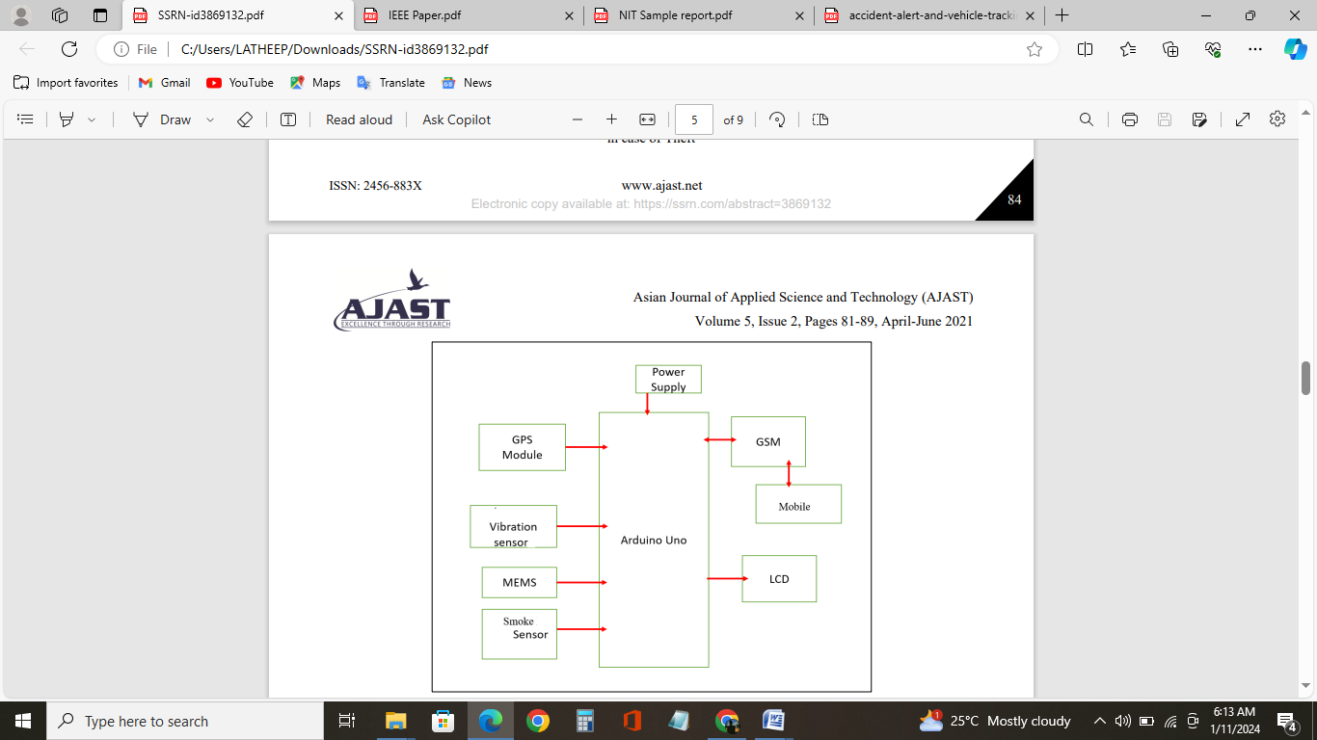

3.2.PROJECT DESCRIPTION
This system consists of two main parts. The first part detects whether the vehicle has fallen down or met with any impact or any fire accident has taken place. This module consist of three sensors namely, Piezoelectric sensor transducer, MEMS, Smoke sensor. Once the vehicle accident is detected the information is send to the second part of the system. The second part consists of an Arduino uno, GSM module, GPS module. When any of the three sensors gets activated based on the level of impact then the micro-controller Atmega in the Arduino fetches the location from the GPS receiver and sends the corresponding information to the contact number mentioned in the code which is dumbed in the Arduino i.e., to near and dear one’s via SMS.
3.3.LIMITATIONS
- MEMS, and Smoke sensor may have limitations in accurately detecting certain types of accidents or impact levels. Smoke sensors are designed for fire detection and may not be as responsive to other accident scenarios.
- Arduino Uno, while versatile, may have limitations in terms of processing power and capability, affecting the speed and efficiency of data processing.
- Depending on the sensitivity settings of the sensors, the existing project may have limitations in accurately distinguishing between minor disturbances and actual accidents, leading to false positives or negatives.
- The compatibility and integration of the sensors with Arduino Uno may limit the overall flexibility and expandability of the system.

4.PROPOSED METHOD
Vibrtion sensor

4.1.Block Diagram
Power Supply

Intel
Galileo
Gen 2
GPS

Accelerometer
GSM

Sound Sensor
Alcohol sensor

4.2.PROJECT DESCRIPTION
"Safety Route Shield" a cutting-edge vehicle safety system designed to enhance accident detection and ensure responsible driving. Powered by the Intel Galileo Gen 2 board, our project employs an array of intelligent sensors, including a vibration sensor, accelerometer, alcohol sensor, GPS, GSM, and a sound sensor. The system operates dynamically, monitoring changes in vibration, acceleration, and car angle, promptly sending an SMS via GSM with precise GPS location details in the event of an accident. The alcohol sensor acts as a vigilant guardian, detecting alcohol consumption and sending immediate alerts if the driver is under the influence. Additionally, our sound sensor enhances the system's accuracy by detecting the intensity of impact sounds during accidents, ensuring swift SMS notifications. Aptly named Safety Route Shield, this project aims to significantly boost road safety by providing a comprehensive, real-time monitoring and alert system for accident prevention and responsible driving.
4.3.ADVANTAGES
1. Accident Detection due to the combination of vibration, acceleration, and sound sensors ensures a comprehensive approach to accident detection.
2.Prevention of Drunk Driving - The alcohol sensor promotes road safety by alerting authorities when alcohol consumption is detected.
3.Intel Galileo Gen 2 offers a more powerful processing unit, potentially allowing for faster and more sophisticated data analysis and decision-making.
4.The use of Intel Galileo Gen 2 provides a platform that may offer better integration capabilities

5.HARDWARE COMPONENTS
5.1.INTEL GALILEO GEN 2
The 2nd generation Intel Galileo board provides a single board controller for the maker community, students, and professional developers. Based on the Intel Quark SoC X1000, a 32-bit Intel Pentium processor-class system on a chip (SoC), the genuine Intel processor and native I/O capabilities of the Intel Galileo board (Gen 2) provide a full-featured off ering for a wide range of applications. Arduino-Certifi ed and designed to be hardware-, software-, and pin-compatible with a wide range of Arduino Uno R3 shields, the Intel Galileo Gen 2 board also provides a simpler and more cost-eff ective development environment compared to the Intel Atom processor- and Intel Core processor-based designs
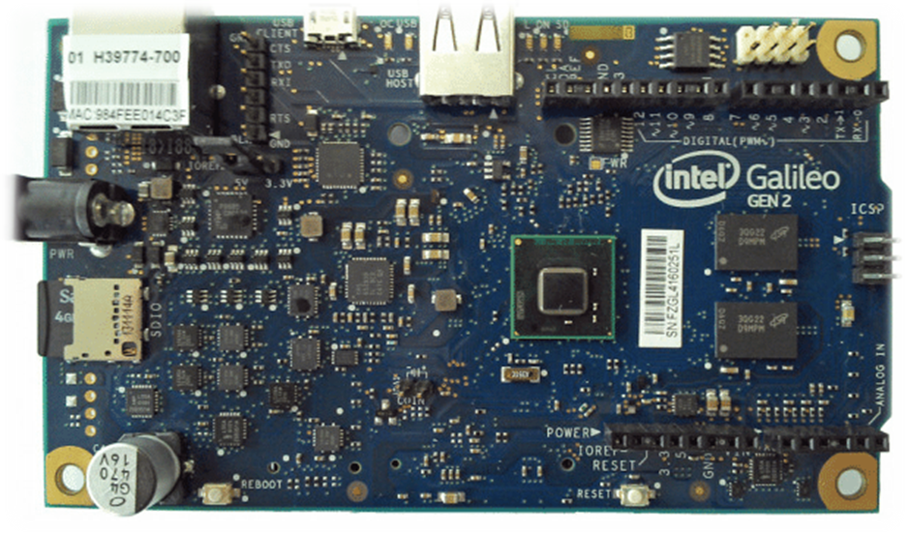

Features & Specifications
• 12 GPIOs fully native for greater speed and improved drive strength.
• 12-bit PWM for more precise control of servos and smoother response.
• 12 V Power-over-Ethernet capable.
• Power supplies from 7 V to 15 V are supported.
• Serial console UART header is compatible with FTDI USB converters.
• Console UART1 can be redirected to Arduino headers in sketches, which can eliminate the need for soft-serial.
• Full-sized mini-PCI Express slot
• 10/100 Mbps Ethernet RJ45 port with PoE support
• Micro-SD slot
• TTL UART 6-pin header
• USB 2.0 Host port
• USB 2.0 Client port
Open Source Hardware
The Intel Galileo board (Gen 2) is an open source hardware design. Schematics, Cadence Allegro board fi les, and bill of materials (BOM) are freely available for download.

Pin Diagram
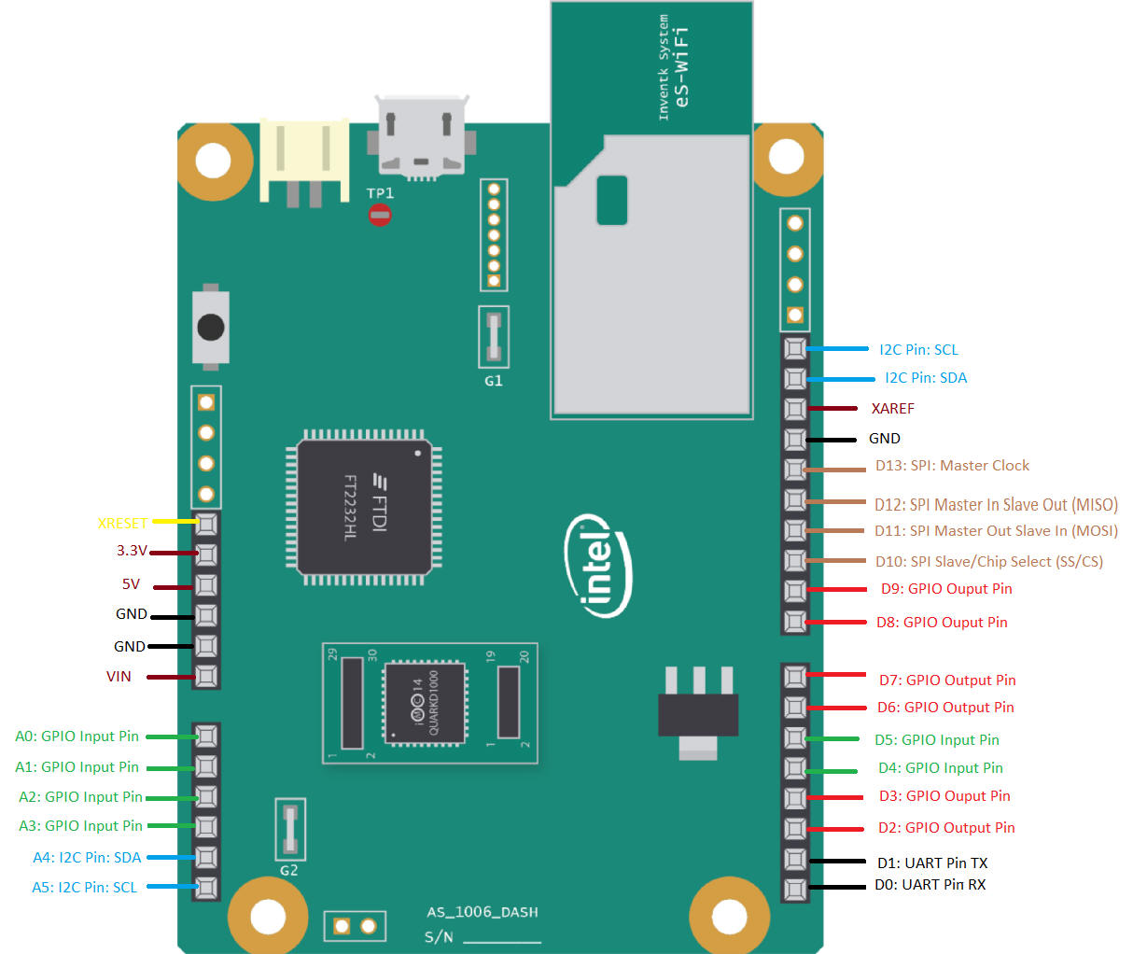

5.2.MPU6050 ACCELEROMETER

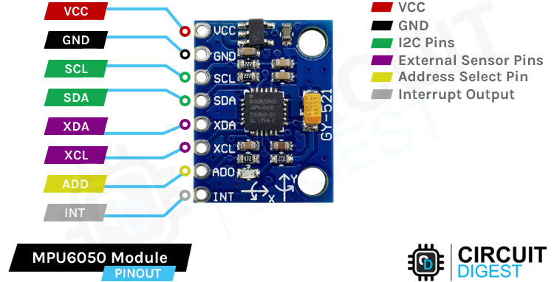
A MEMS (Micro-Electro-Mechanical System) accelerometeris a micro-machined structure built on top of a silicon wafer.This structure is suspended by polysilicon springs. It allows the structure to deflect when accelerated along the X, Y, and/or Z axes.As a result of deflection, the capacitance between fixed plates and plates attached to the suspended structure changes. This change in capacitance is proportional to the acceleration along that axis.The sensor processes this change in capacitance and converts it into an analog output voltage.While accelerometers measure linear acceleration, gyroscopes measure angular rotation. To accomplish this, they measure the force generated by the Coriolis Effect.
Hardware Overview
At the core of the module is a low-power, low-cost 6-axis MotionTracking chip – MPU6050 – that integrates a 3-axis gyroscope, 3-axis accelerometer, and a Digital Motion Processor (DMP) into a tiny 4mm x 4mm package.It can measure angular momentum or rotation along all three axes, static acceleration caused by gravity, and dynamic acceleration caused by motion, shock, or vibration.
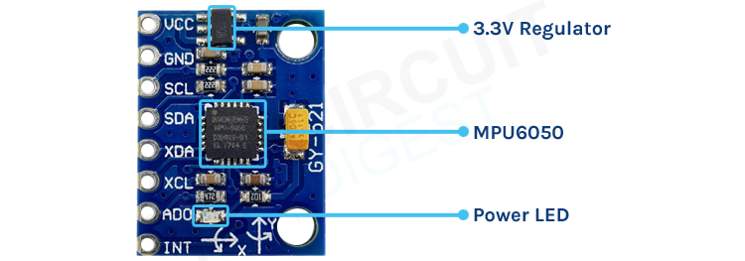
Technical Specifications
Operating Voltage - 5V (typical)
Accelerometer Range - ±2g, ±4g, ±8g, ±16g
Gyroscope Range - ±250°/s, ±500°/s, ±1000°/s, ±2000°/s
Temperature Range - (-40 to +85°C)
Absolute Maximum Acceleration - Up to 10,000g

5.3.SW420 VIBRATION SENSOR
The vibration sensor module based on the vibration sensor SW-420 and Comparator LM393 is used to detect vibrations. The threshold can adjust using an on-board potentiometer. During no vibration, the sensor provides Logic Low and when the vibration is detected, the sensor provides Logic High. This Vibration Sensor Module consists of an SW-420 Vibration Sensor, resistors, capacitor, potentiometer, comparator LM393 IC, Power, and status LED in an integrated circuit.Vibration sensor module consists of three pins i.e. VCC, GND, and DO. The Digital out pin is connected to the output pin of the LM393 comparator IC

Features & Specifications
- Operating Voltage: 3.3V to 5V DC
- Operating Current: 15mA
- Using SW-420 normally closed type vibration sensor
- LEDs indicating output and power
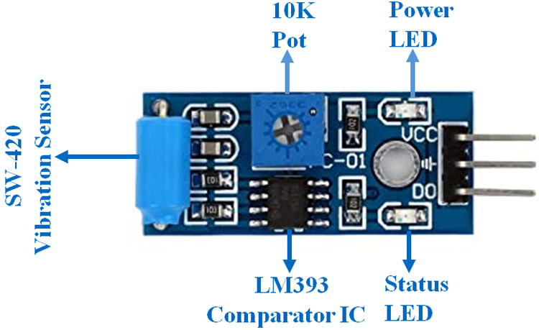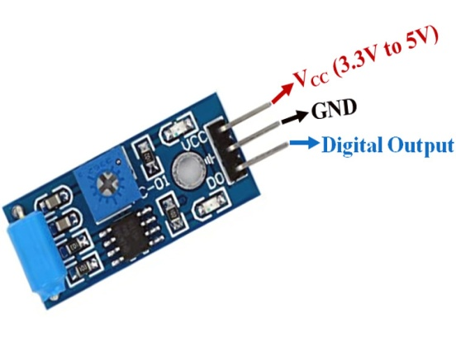

Applications of Vibration Sensor Module
- Shocks triggering
- Theft alarm
- Smart car
- Earthquake alarm
- Motorcycle alarm
5.4.NEO 6M GPS MODULE
NEO 6M GPS uses the latest technology to give the best possible positioning information and includes a larger built-in 25 x 25mm active GPS antenna with a UART TTL socket. A battery is also included so that you can obtain a GPS lock faster. This is an updated GPS module that can be used with ardupilot mega v2. This GPS module gives the best possible position information, allowing for better performance with your Ardupilot or other Multirotor control platform.
The GPS module has serial TTL output, it has four pins: TX, RX, VCC, and GND. You can download the u-center software for configuring the GPS and changing the settings and much more. It is really good software

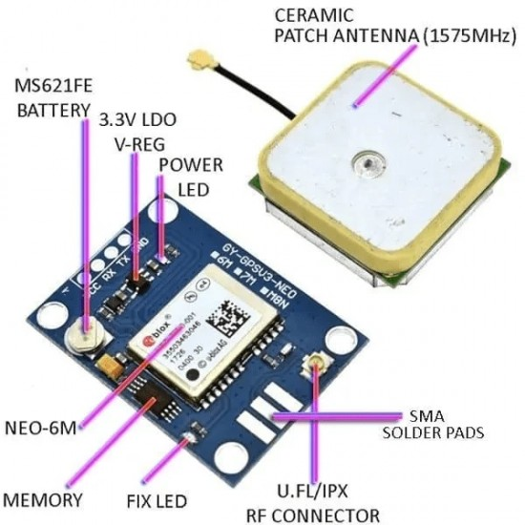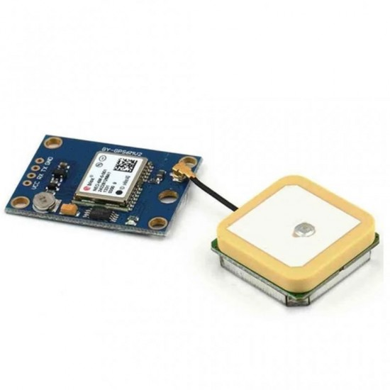

Features
- 5Hz position update rate
- Operating temperature range: -40 TO 85°CUART TTL socket
- EEPROM to save configuration settings
- Rechargeable battery for Backup
- The cold start time of 38 s and Hot start time of 1 s
- Supply voltage: 3.3 V
- Configurable from 4800 Baud to 115200 Baud rates. (default 9600)
- SuperSense Indoor GPS: -162 dBm tracking sensitivity
- Support SBAS (WAAS, EGNOS, MSAS, GAGAN)
- Separated 18X18mm GPS antenna

5.5. SIM800C GSM MODULE
The SIM800C Module is a popular GSM unit with a serial modem and operates within a voltage range of 3.4V to 4.4V. It is designed for use in projects where transfer of data is needed and can connect to four different frequencies. The SIM800C can make and receive calls and send and receive text messages with low energy consumption. It is controlled using special AT commands and can only support one card of SIM. The module has special pins for communication (TX and RX) and can connect to different microcontrollers using the RS232 serial protocol
One can insert a card of SIM into the back side of the SIM800C module GSM. Remember that this module does not work with 4G SIM cards, so only use a regular card SIM. 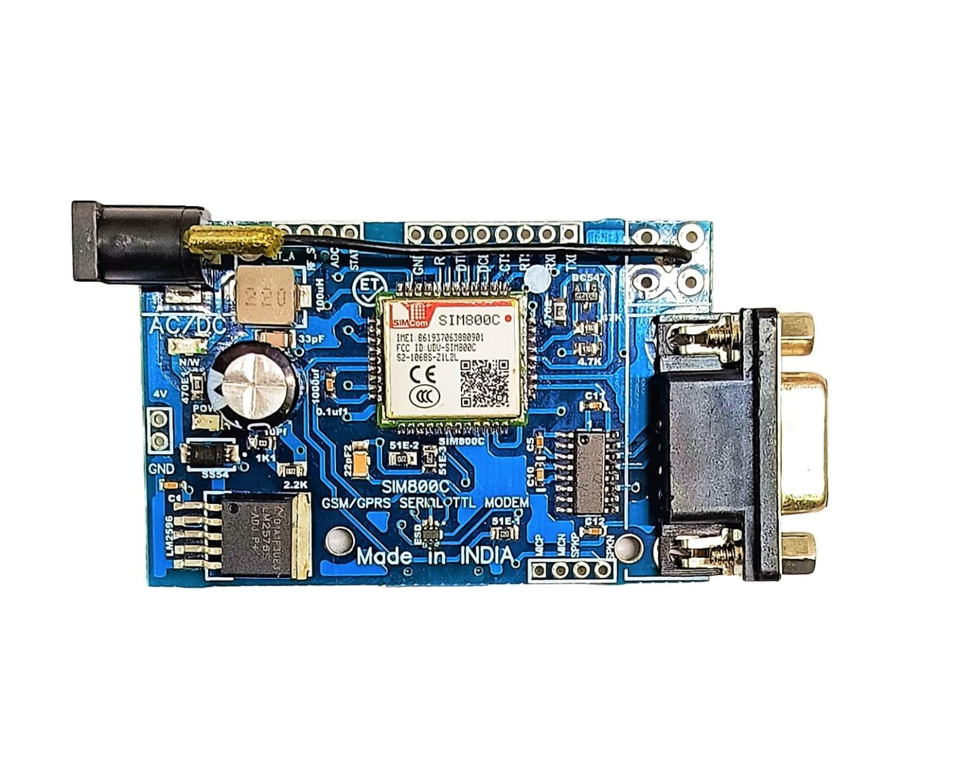

Features of SIM800C GSM MODULE
- Works with four frequency bands: GSM850, EGSM900, DCS1800, and PCS1900.
- Connect to any global 2G GSM network using any 2G SIM card
- Send & receive SMS
- Send & receive GPRS information
- Scan & receive FM broadcasts
5.6. MQ3 ALCOHOL SENSOR
It is a low cost semiconductor sensor which can detect the presence of alcohol gases at concentrations from 0.05 mg/L to 10 mg/L. The sensitive material used for this sensor is SnO2, whose conductivity is lower in clean air. It’s conductivity increases as the concentration of alcohol gases increases. It has high sensitivity to alcohol and has a good resistance to disturbances due to smoke, vapor and gasoline. This module provides both digital and analog outputs. MQ3 alcohol sensor module can be easily interfaced with Microcontrollers. This alcohol sensor is suitable for detecting alcohol concentration on your breath, just like your common breathalyzer. It has a high sensitivity and fast response time. Sensor provides an analog resistive output based on alcohol concentration. The drive circuit is very simple, all it needs is one resistor. A simple interface could be a 0-3.3V ADC.
Features
- 5V operation
- Simple to use
- LEDs for output and power
- Output sensitivity adjustable
- Analog output 0V to 5V
- Digital output 0V or 5V

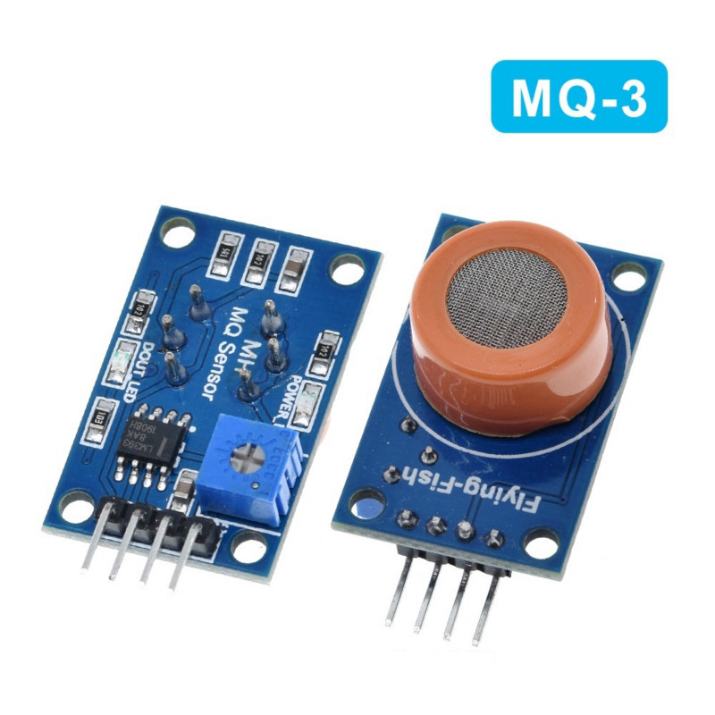
Technical Data
- Concentration : 0.05 mg/L ~ 10 mg/L Alcohol
- Operating Voltage : 5V ±0.1
- Current Consumption : 150mA
- Operation Temperature : -10°C ~ 70°C
5.7. LM393 SOUND SENSOR
Sound detection sensor module detects the intensity of sound where sound is detected via a microphone and fed into an LM393 op-amp. It comprises an onboard potentiometer to adjust the setpoint for sound level. This Sound Detection Sensor Module consists of a Microphone, resistors, capacitor, potentiometer, comparator LM393 IC, Power, and status LED in an integrated circuit.

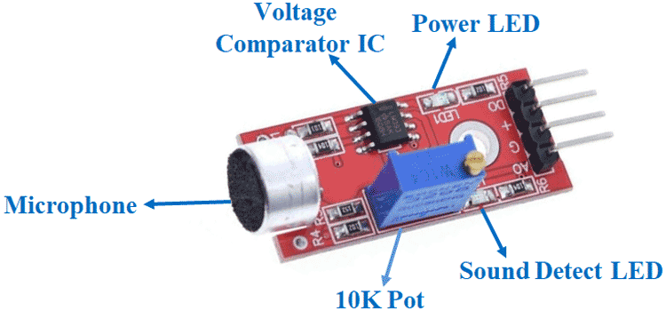

Features & Specifications
- Operating Voltage: 3.3V to 5V DC
- LM393 comparator with threshold preset
- PCB Size: 3.4cm * 1.6cm
- Induction distance: 0.5 Meter
- Operating current: 4~5 mA
- Microphone Sensitivity (1kHz): 52 to 48 dB

Applications
- Hearing aids
- Telephones
- Tape recorders and karaoke
- Live and recorded audio engineering
- Speech recognition technology

6.SOFTWARE TOOL
Arduino IDE
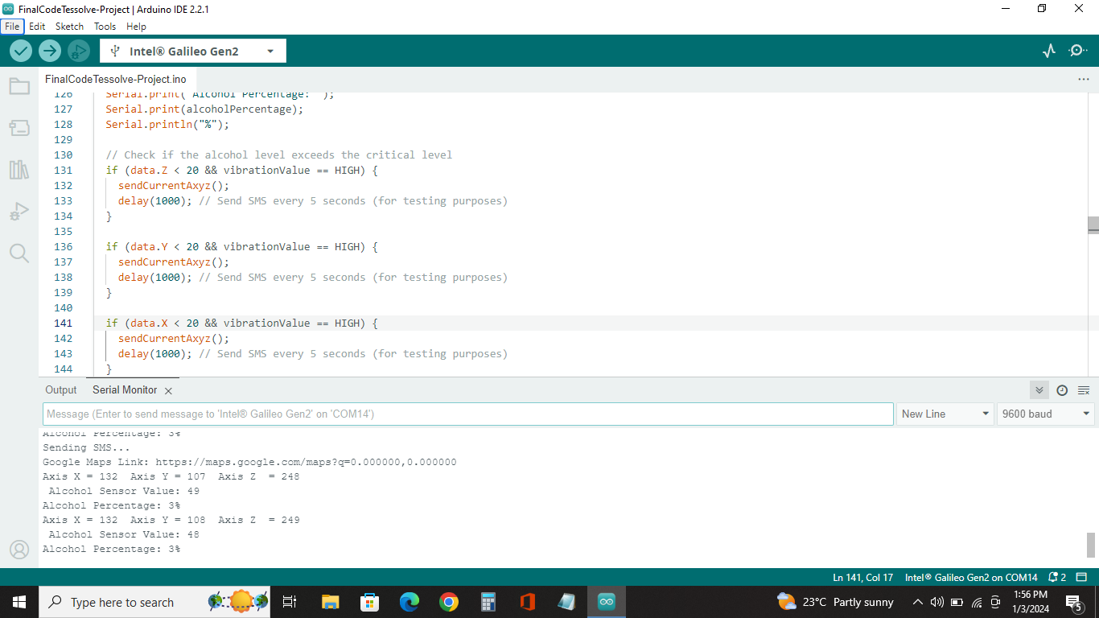
In our SafetyRoute Shield project, we leverage the versatile Arduino IDE as the software tool for programming the Intel Galileo Gen 2 board. The Arduino IDE (Integrated Development Environment) serves as a user-friendly platform, simplifying the coding process for our embedded system. With its intuitive interface and extensive library support, the Arduino IDE streamlines the development of functionalities, ensuring seamless integration between our chosen sensors and the Intel Galileo Gen 2 board. This powerful combination of hardware and software facilitates efficient programming, enabling us to harness the full potential of the Intel Galileo Gen 2 for real-time accident detection and responsive communication through SMS alerts.

7.RESULTS
ACCIDENT ALERT SMS
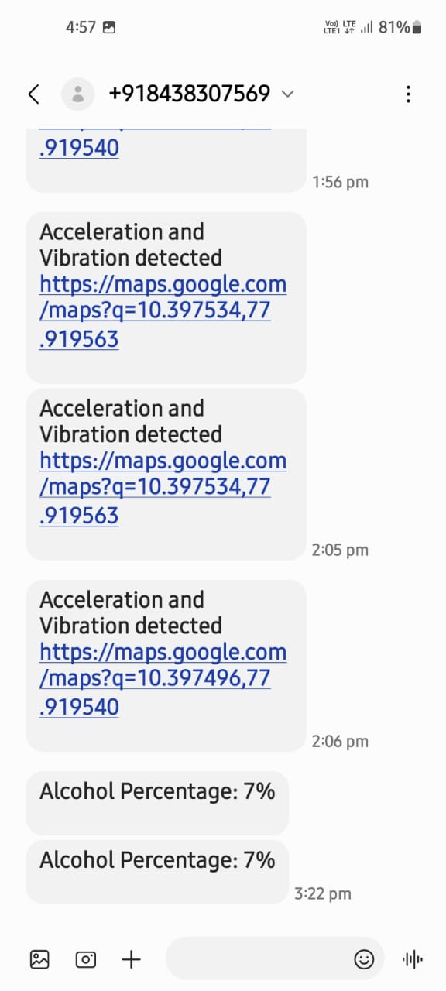
LOCATION
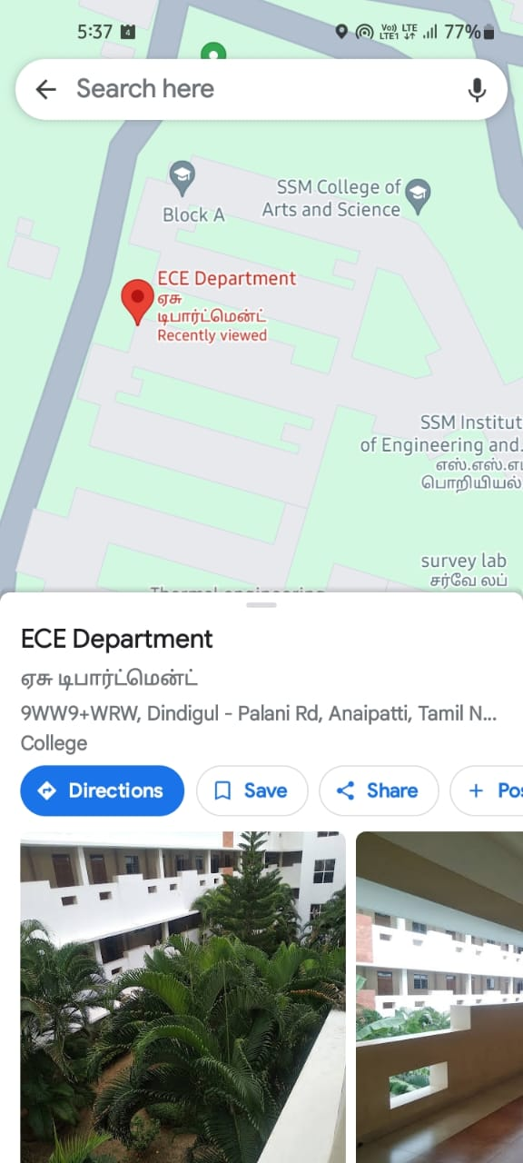
HARDWARE 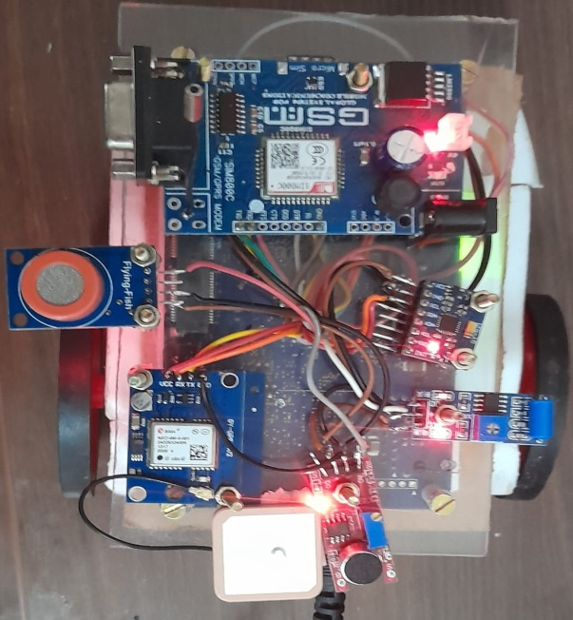
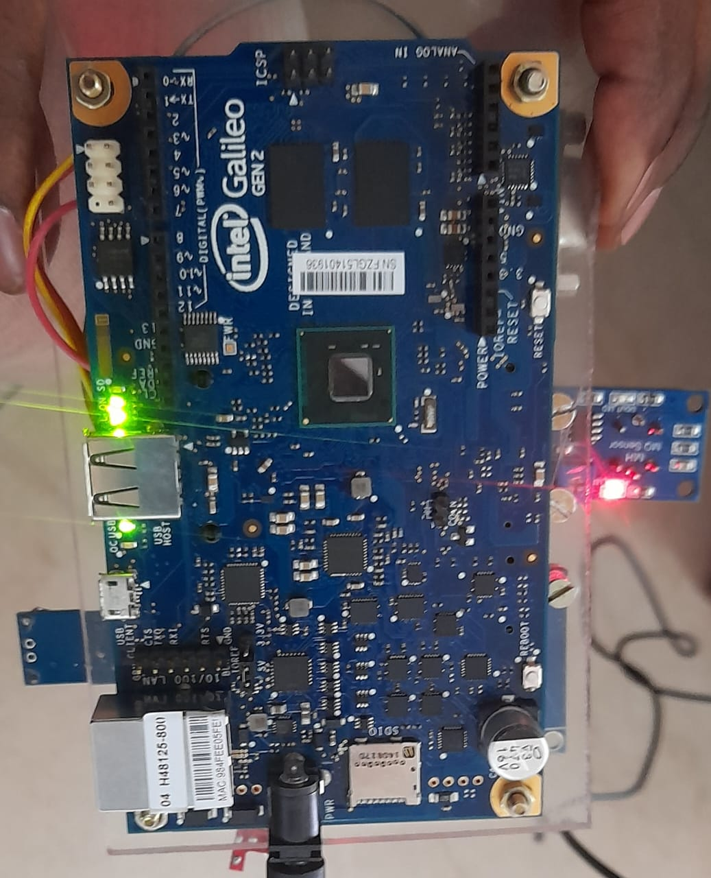

8.Conclusion
In summary, SafetyRoute Shield, utilizing the Intel Galileo Gen 2 and Arduino IDE, offers a powerful and user-friendly solution for real-time accident detection and responsible driving. With an array of advanced sensors, the system ensures swift SMS alerts with precise GPS details, enhancing road safety and discouraging drunk driving. This project embodies a commitment to leveraging technology for public safety, providing a practical tool for accident prevention and rapid emergency response on the roads.

9.REFERENCES
1. Racheal Dias, Vishakha Ghike, Jennifer Johnraj, Nicholas Fernandes, Anita Jadhav Department of Electronics and Telecommunication, Fr. Conceicao Rodrigues Institute of Technology, Vashi, Navi Mumbai, India
2. Dr. Avinash Chandra, Rishab Kaul, Shaanvi Mehta, Subharthi Saha Vellore Institute of Technology
3. J. Mounika1 , N. Charanjit2 , B. Saitharun3 & B. Vashista4 1Assistant Professor, Dept. of ECE, Chaitanya Bharathi Institute of Technology, Osmania University, Hyderabad, Telangana, India. 2,3,4BE Scholar, Dept. of ECE, Chaitanya Bharathi Institute of Technology, Osmania University, Hyderabad, Telangana, India.

